Brain Langolf
September 2020 - December 2020

UWO Biogas
Emma Klein, Project Coordinator, emmaklein@live.com
Nolan Knight, knighn98@uwosh.edu
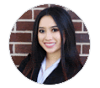
Emily Togstad, togste99@uwosh.edu
Kiara Petty, pettyk84@uwosh.edu
Ka Vang, Videographer/Video Editor vangk95@uwosh.edu







Client Background:
A large part of why the university was ranked as a national leader in sustainability is due to the UW Oshkosh Biogas Systems. It is nationally recognized and affiliated with the American Biogas Council, the only national trade association representing the entire biogas industry in the U.S. As part of the University of Wisconsin Oshkosh’s mission to become a more sustainable institution, UW Oshkosh and partners have constructed the nation’s first commercial-scale dry fermentation anaerobic biogas system on campus, and two biogas systems at dairy farms. This program converts organic waste into energy, producing natural gas and soil additives like compost and fertilizer.
The University of Wisconsin Oshkosh’s mission to become a more sustainable institution is contributing to the renewable energy movement. Renewable energy provides reliable power and fuel diversification. It helps conserve the nation’s natural resources. Biogas is a simple technology that encourages a circular economy. UWO Biogas Systems would like to expand their presence in the marketplace with community partners by improving their online presence. The goal is to redesign the website and develop videos, photos and other digital assets to virtually show what UWO Biogas Systems is all about.
Biogas is defined as a biofuel that is naturally produced from the decay of organic waste (“What is Biogas?,” 2020). The system releases methane and carbon dioxide that can generate natural gas or soil. Biogas solutions can contribute to resource efficiency in several ways. The energy carrying biogas is a by-product of processes such as anaerobic digestion of sewage sludge, waste-water treatment from process industry, or generated as landfill gas (“What is Biogas”, 2020).
Sustainability is important because “we cannot maintain our quality of life as human beings, the diversity of life on Earth, or Earth’s ecosystems unless we embrace it” (H, 2017). Sustainability is a way of interacting with the planet to maintain natural resources (“What is Environmental Sustainability,” 2020).
UWO works alongside partners such as the Center for Sustainable Enterprise (CSE), Environmental Research and Innovation (ERIC), Sustainability Institute for Regional Transformations (SIRT), STEM Outreach and more (“UW Oshkosh Biogas Systems,” 2019).
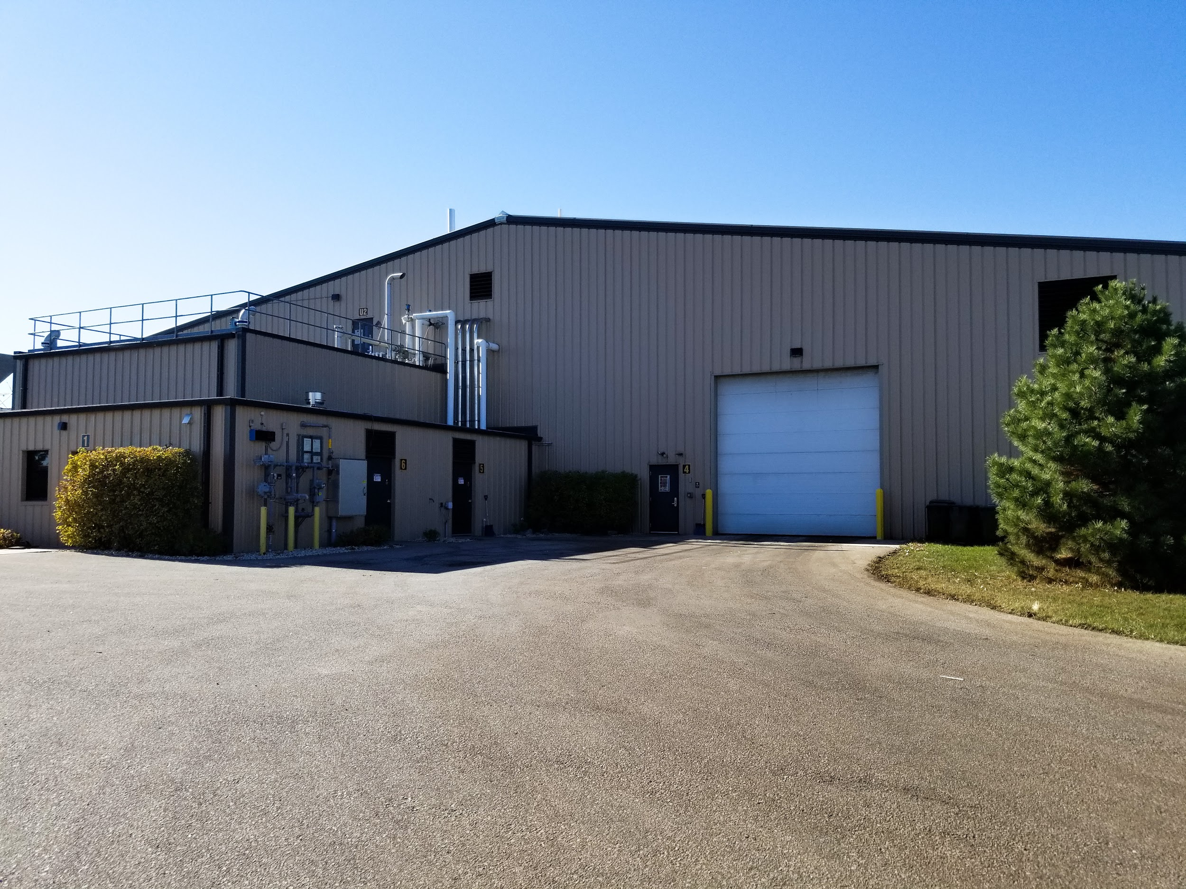
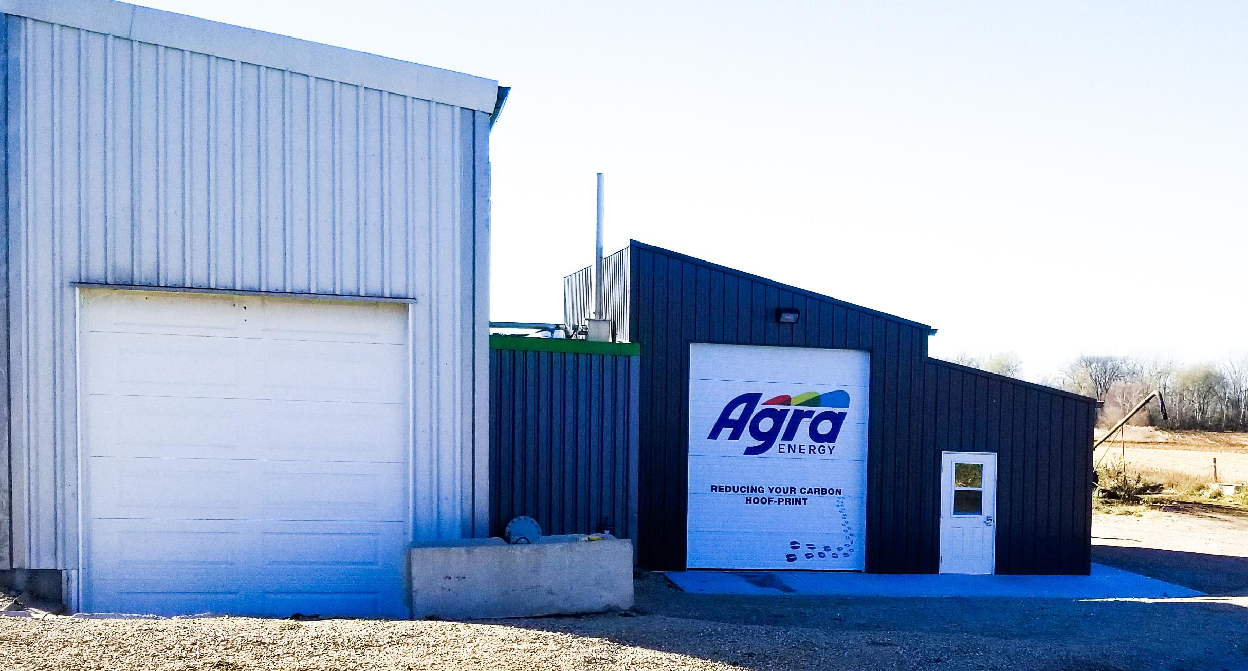

Thank your Brian for giving us the opportunity to work with you on this project. It was an educational experience that helped us toward our future careers.
Situation statement and objectives:
UW Oshkosh and partners have created the nation’s first commercial-scale dry fermentation anaerobic biogas system on campus, plus two biogas systems located at dairy farms. Biogas is a simple technology that encourages a circular economy. Our client, UWO Biogas Systems, would like to expand their presence in the marketplace with community partners by improving their online presence. The goals for our client are to redesign the website and develop videos, photos and other digital assets to virtually show what UWO Biogas Systems is all about for example what the biogas is, who they are, what they do, and how they help the community.

Brian Langolf the director of the Biogas Program said the goal for this project is, “We want to show what the biogas is, who we are and what we do.”
He later provided more details on his goals for the UWO Biogas Program website. “Other things to keep in mind that the website should highlight. Our main focus areas for the Biogas Program are: 1) Sustainability - Help meet and achieve the sustainability goals of our campus through the use of our renewable energy infrastructure, 2) Education and Research - Be a resource for our students and faculty to advance education and research initiatives 3) Community Engagement - Be a resource for the broader community through education, training, consulting, research, organics diversion, etc..”
A previous group has worked on this project. They created branding guidelines, social media best practices, personas, a mission statement and a wireframe that are used in this work and can be used in future projects. Our group’s website/videos highlights new content and programs such as the virtual tours of the facilities and the food waste pickup program.
How Project Relates to National Trends:
For renewable energy non-profits, some best practices include highlighting the benefits of the industry. As well as decreasing concerns people may have about a technology that is new to them.
From the AgSTAR Project Development Handbook
- Showing the benefits biogas bring to the community
- Environmental benefits: cleaner air, less pollution and reduced waste
- Economic benefits: biodigesters create jobs, energy, compost, and reduce garbage entering landfills (EPA, “AgSTAR Project Development”, 2014).
Some best practices for video and photos for biogas websites are shown on the Ameresco website. For example, in one of their videos, they discuss a wastewater treatment facility where the waste is now being turned into biogas. They show the facility, describe how the process works, then go into how the project helps the community such as reducing pollution, job growth, the amount of energy produced, and money earned from the gas. People involved in the project also give testimonials about different aspects of the project. High-quality pictures also show this content (Ameresco, “Distributed Generation, Microgrids & Storage”, 2020).
Greenfire, a local biogas company shows similar trends in the industry; they have a simple page layout and design, while clearly showing what they do. They include videos, worksite photos, team photos and partner infographics to make their content easy to understand (Greenfire, “Greenfire”, 2020).
Videos are a way to share a story by showing people working with others, they are fast and convenient and keep the audience interested. A good rule of thumb is to include white space to focus a visitor's attention on the video (10 Website Design Best Practices for Nonprofits, 2020). Additionally, if an organization has a video they will typically be located on their home page, to draw a viewer’s attention. And if a person in the video is introduced for an interview or testimonial their name and any relevant information about them, such as a job title, will be placed in a text box in the frame.
All of the content on these websites matches the best practices described above. And best practices Motocms and Creative Nurds features in their articles about best practices for renewable energy websites (Motocms, “Renewable Energy Website Templates”, 2020) and (Creative Nurds, “10 Best solar energy website examples”, 2020).
Another website best practice Motocms suggests and these biogas organizations follow is technology companies must have a high quality website. This is because customers may not trust a company that says they are high tech but can’t make a high quality site that includes things like eye-catching photos, well organized content and videos (Motocms, “Renewable Energy Website Templates”, 2020).
While not a direct competitor the American Biogas Council does show some good best practices for photos and infographics for nonprofits in the biogas industry. Such as using infographics to describe the complex process of turning waste products into energy (American Biogas Council, “Why Biogas”, 2020). Additionally, according to Motocms, pictures should be large, high-quality and easy to read (Motocms, “Renewable Energy Website Templates”, 2020).
Some best practices for the website design include using good content organization, large text and having an accessible design. Don’t use colors that are too light or clash. The video, photo, and infographic best practices are included in the overall website design.
Target Audience and Strategy
We wanted to create an informative website design to direct all target audiences to the right place to answer their questions. An improvement we made was having three call outs in yellow on each website page. The calls to action are “Learn more”, “Take a Virtual Tour”, and “Get Involved”. The “Learn more” button takes the user to the “About” page to learn more about Biogas. The “Take a Virtual Tour” button takes the user to a page where they can either schedule a tour or take a virtual one. The most important page on the Biogas Systems website we created is the“Get Involved” page. This page is separated into three distinct sections, Business Owners, Community, and Students. Each section has links sending the particular audience to more information. Biogas Systems is trying to reach many audiences in two categories, the UW Oshkosh Campus and the Oshkosh Community. A previous group worked to help develop these target audience personas.
University of Wisconsin Oshkosh Campus
- Faculty & Staff
The purpose of Faculty or Staff to seek out our page would be to schedule tours or educate themselves or their students on renewable energy. The Faculty and Staff of UW Oshkosh may not know much about Biogas Systems unless they are a part of it. It was important to us as a team to inform Faculty and Staff on what Biogas is and how it’s important.
- Students
The purpose of Students visiting our website would be to educate themselves on renewable energy or if they are interested in touring our facility. Future students or current students might have an interest in sustainable energy. We wanted to create a good resource for students.
- Club Advisers
Club advisers would come to the Biogas Systems website to either schedule a tour or educate themselves about Biogas.Creating awareness is important. On each page of the website we have call outs which direct the audience to a tours page. Because of Covid-19, it was important to have virtual tours easily accessible to the public.
Oshkosh Community
- Local Businesses
The purpose of a local business seeking out our page would be to donate food waste or learn more about creating a sustainable business. Having a sustainable business has many benefits. There was no section to inform businesses before. Brian wanted to grab the attention of businesses in the area. On the “Get Involved” page we have links that direct business owners on how to start donating their waste.
- Local Farmers
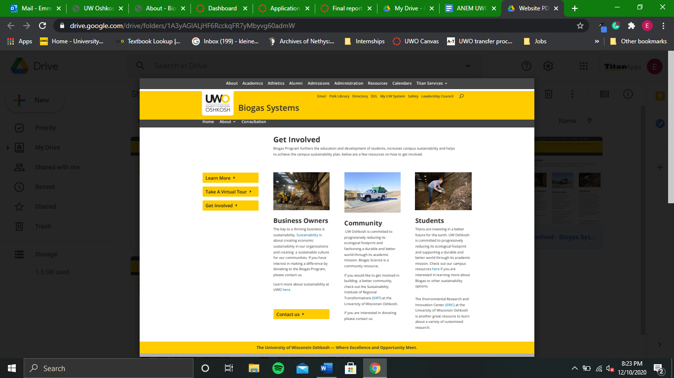
Local Farmers may be looking to cut down costs and are interested in partnering with Biogas Systems. Local Farmers fit into the same category as business owners. The links in the “Get Involved” section of the website are informative and directs this audience to get in contact with Brian.
- Biogas Consulting Community
Biogas Systems has many businesses consulting with them. More companies are seeking sustainability. Businesses, project developers, and engineering companies are looking for best practices to begin their renewable energy journey. Businesses should easily be able to find the contact information on the Biogas Systems website.
This content will have a knowledgeable voice because it is on a high technology subject. We chose to improve the website platform because it makes the site more trustworthy, authoritative and connects better with our target audiences. Renewable energy website builders like Motocms and Creative Nurds said that high quality website is essential for a high tech company (Motocms, “Renewable Energy Website Templates”, 2020) and (Creative Nurds, “10 Best solar energy website examples”, 2020).
According to Langolf we could improve the website's quality by connecting more with its target audiences and “ Be a resource for our students and faculty to advance education and research initiatives”. Before the website was redesigned it did not connect well with its target audiences. But with the new “Get Involved” page the website connects much better with the many target audiences.

Project deliverables
Our main strategy for the website redesign was to have a big focus on calls to action, and to rework some of the content on the website. Keeping best practices for website design in mind, we also wanted to clean up a lot of the content and navigation on the website, to make the overall website more appealing and easier to use. One strategy we used was creating different calls to action, and placing them on every page. The three main calls to actions we used was Learn More, Take a Virtual Tour, and Get Involved. The Learn More call to action links to the about page, where people can learn more about the Biogas Program, and how they operate. The Virtual Tour call to action links to a virtual tour that UWO Biogas had created for us, and allows users to take a virtual tour of both of their facilities. Lastly, the Get Involved call to action links to a page where we try to connect with their target audience. This page gives information about how local businesses, community organizations, and students can get involved with the Biogas Program. Another strategy we used was writing new copy for different pages of the website, but specifically the home page. One big change we made to the home page was putting a mission statement on it. This lets visitors know what purpose the Biogas Program serves, and what its goals are. Lastly, we focused on changing the content on the website. Before the redesign, a lot of the images and content on the website were lackluster and boring to look at. According to DeepBlue, a good practice for website design is to focus on the content of the website. The content should be centered around the organization, and reflect what they do.
Additional content we created as a part of this project includes the social media guide, video, images and infographics. This content can be used on the website or on social media to direct people towards the site. The content we created serves three main purposes: to share information about UWO Biogas, to explain complicated concepts and to show off the biogas facilities and process. The videos feature Brian Langolf discussing what the biogas program means for the university and the community. The images show two of the biogas facilities and the images explain the energy impacts of biogas in Wisconsin. We decided to do these videos, images and infographics because they would keep audiences engaged in the topic and make the site look more eye-catching and professional. According to SWEOR, the aesthetic of a website's content is extremely important, “75% of consumers admit to making judgments on a company’s credibility based on the company’s website design” (SWEOR, 2020). This means any videos, photos or infographics a site has must be high quality. UMC must approve this website before it can go live.

Deliverable 1:
Social Media Guide:
The goal of the social media policy is to give the UWO Biogas program all the information they need to start social media accounts. This includes social media best practices such as the ratio of promotion to personal stories. Some example posts and employee posting guidelines. And best platforms to post on. This guide is based on best practices because according to Todd Clarke at Hootsuite, it is important to “[l]earn everything you can about your audience” (Clarke, 2020). Based on this knowledge, we added LinkedIn to the list of platform suggestions because it is popular among professionals, a group UWO Biogas is interested in. Much of this policy was created by a group who previously worked on this project.
The strategy for the social media policy is to connect with business professionals and students on LinkedIn and community members, students, staff and faculty over Facebook and Instagram.
Here is an excerpt from the policy.
The most important thing to remember when posting on social media, is listen to your audience and pay attention to what they’re saying about you. In the Tufts University Communications and Marketing social media guidelines and best practices, they continuously state how incredibly important it is to listen to your audiences on all of your social media accounts. They state, “Let your fans speak. People may sometimes comment on a post or post something on your page’s wall that is critical or negative. Correcting a mistake, apologizing and offering better in the future, or providing information about the event in question is often the best way to let the poster know you have heard them,” (Tufts, 2019).

Deliverable 2:
Website:
Our main strategy for the website redesign was to have a big focus on calls to action, and to rework some of the content on the website. Keeping best practices for website design in mind, we also wanted to clean up a lot of the content and navigation on the website, to make the overall website more appealing and easier to use. One strategy we used was creating different calls to action, and placing them on every page. The three main calls to actions we used was Learn More, Take a Virtual Tour, and Get Involved. The Learn More call to action links to the about page, where people can learn more about the Biogas Program, and how they operate. The Virtual Tour call to action links to a virtual tour that UWO Biogas had created for us, and allows users to take a virtual tour of both of their facilities. Lastly, the Get Involved call to action links to a page where we try to connect with their target audience. This page gives information about how local businesses, community organizations, and students can get involved with the Biogas Program. Another strategy we used was writing new copy for different pages of the website, but specifically the home page. One big change we made to the home page was putting a mission statement on it. This lets visitors know what purpose the Biogas Program serves, and what its goals are. Lastly, we focused on changing the content on the website. Before the redesign, a lot of the images and content on the website were lackluster and boring to look at. According to DeepBlue, a good practice for website design is to focus on the content of the website. The content should be centered around the organization, and reflect what they do.
Home Page
Our main focus for the home page was to redesign the page to make it more appealing and easier to navigate. We also wanted to incorporate our calls to action there (note that these calls to action are on every page). Using the work from last year’s group, we included the mission statement of UWO Biogas, and the campus sustainability strategic plan.
Get Involved Page
The main goal of this page was to try to better reach their target audience. The three main target audiences for UWO Biogas are local businesses, students, and community partners. On this page we included three different sets of copy, one for each of their target audiences. We also included relevant calls to action for each target audience, as well as linking the whole page on every other page.

Consultation Page
This page was meant to show what service UWO Biogas can offer as far as consultation. It also shows projects and partners that they’ve worked with in the past.
Our Facilities Page
Before our redesign, there were two separate pages for each of their facilities. What we did is combine those two pages into one cohesive page, in order to reduce clutter and make navigation easier.
About Page
This page is meant to describe what UWO Biogas does and how it works. We tried to make it easy to read so that if someone who doesn’t know anything about biogas comes to the website, it would be easier for them to understand.
Contact Us Page
The main content of this page mostly remained the same, aside from updating some contact information, and reworking the layout of the page. We also included a Google Maps embed of the facility in order to reduce some of the whitespace on the page.
Virtual Tour
The virtual tour isn’t a standalone web page, but we did include a link to it on every page of the website. This virtual tour was already provided to us before we began working on the project, and we thought it would be a great way for people to learn more about UWO Biogas virtually.

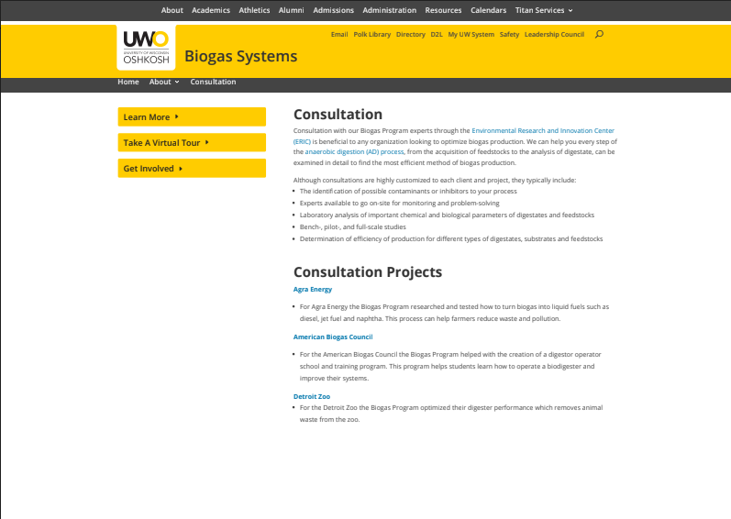

Deliverable 3:
Videos:
The strategy behind our videos is to increase awareness and create engaging content. According to Social Media Today, ”videos keep people on your website longer and engage them with your content.” (Walker-Ford, 2017). Videos are a way to share a story by showing people working with people, they are fast and convenient and keep the audience interested. A good rule of thumb is to include white space to focus a visitor's attention on the video (“10 Website Design Best Practices for Nonprofits”, 2020). The video can tell a story, share goals or educate. This would be more entertaining than having a user just read about it. We plan to place this video on the website, or upload them to social media platforms.
How we achieved this strategy- we recorded small clips of the Biogas Program collection at the University of Wisconsin Oshkosh. This is actually a new program that collects food waste from Blackhawk and Reeve Union. We wanted to make a short clip about this program to drive awareness since it’s new. We also interviewed the director of the program and asked general questions. We then used Adobe Rush to create the video. Originally, the first video we made was 3 minutes long, but since it is best practice to keep the video short, we split it up into three separate one-minute videos. These videos cover three different topics 1.) the Biogas Program collection at UWO 2.) Biogas Program goals and 3.) why it is important and how to get involved. We also added background music.
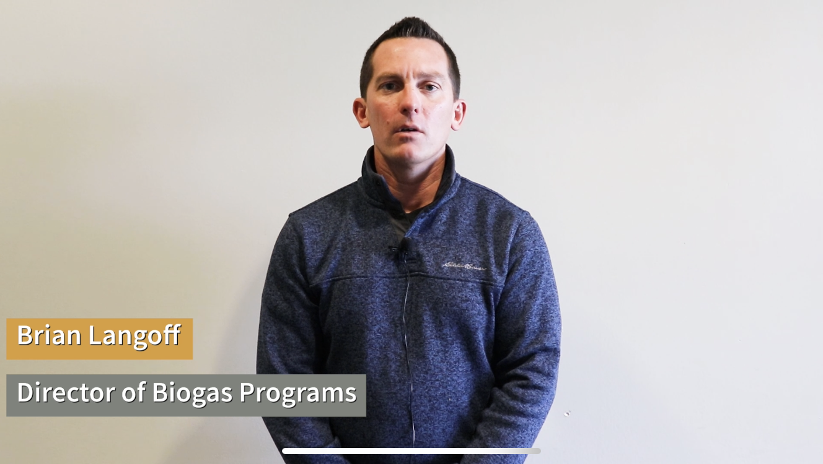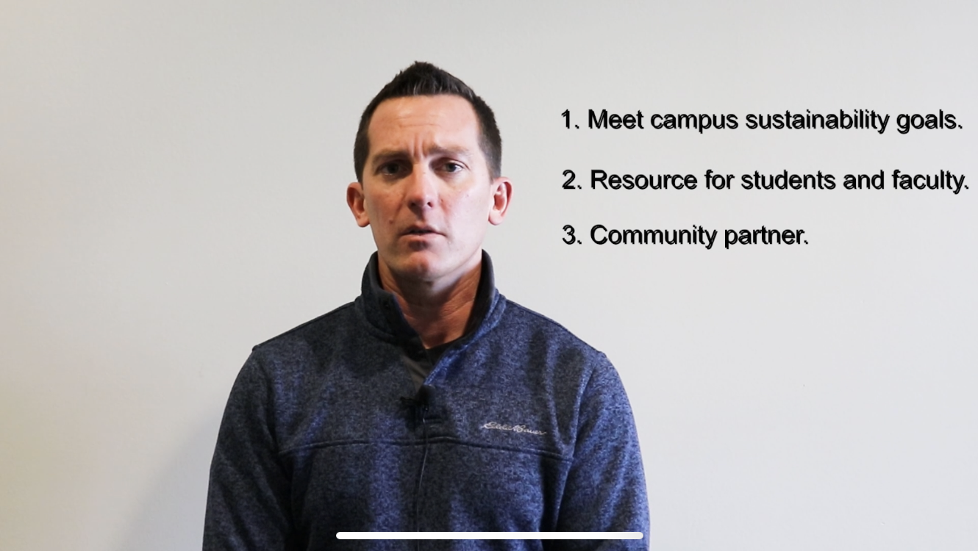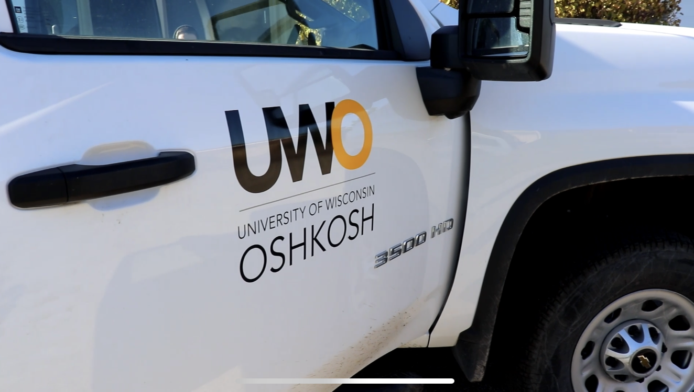

Deliverable 4:
Photos:
The strategy behind our photos was we knew the client wanted to improve the overall look and feel of the website. Motocms and Creative Nurds suggest a website can be improved through large, high quality photos. They also suggest on-site photos that show the alternative energy equipment (Motocms, “Renewable Energy Website Templates”, 2020) and (Creative Nurds, “10 Best solar energy website examples'', 2020). This strategy is backed up by the ABC and other biogas organizations.
We achieved this strategy by going to Urban Anaerobic Dry Biogas Systems and Allen Farms and taking lots of pictures on-site, to give website viewers a real look at the facilities. These photos can be used in any future website updates, in university marketing or on social media.
For brevity, only photos we created and that are featured on the website are included in this section. Other photos of Urban Anaerobic Dry Biogas Systems and Allen Farms that we took but were not included in the website are located in the appendix.

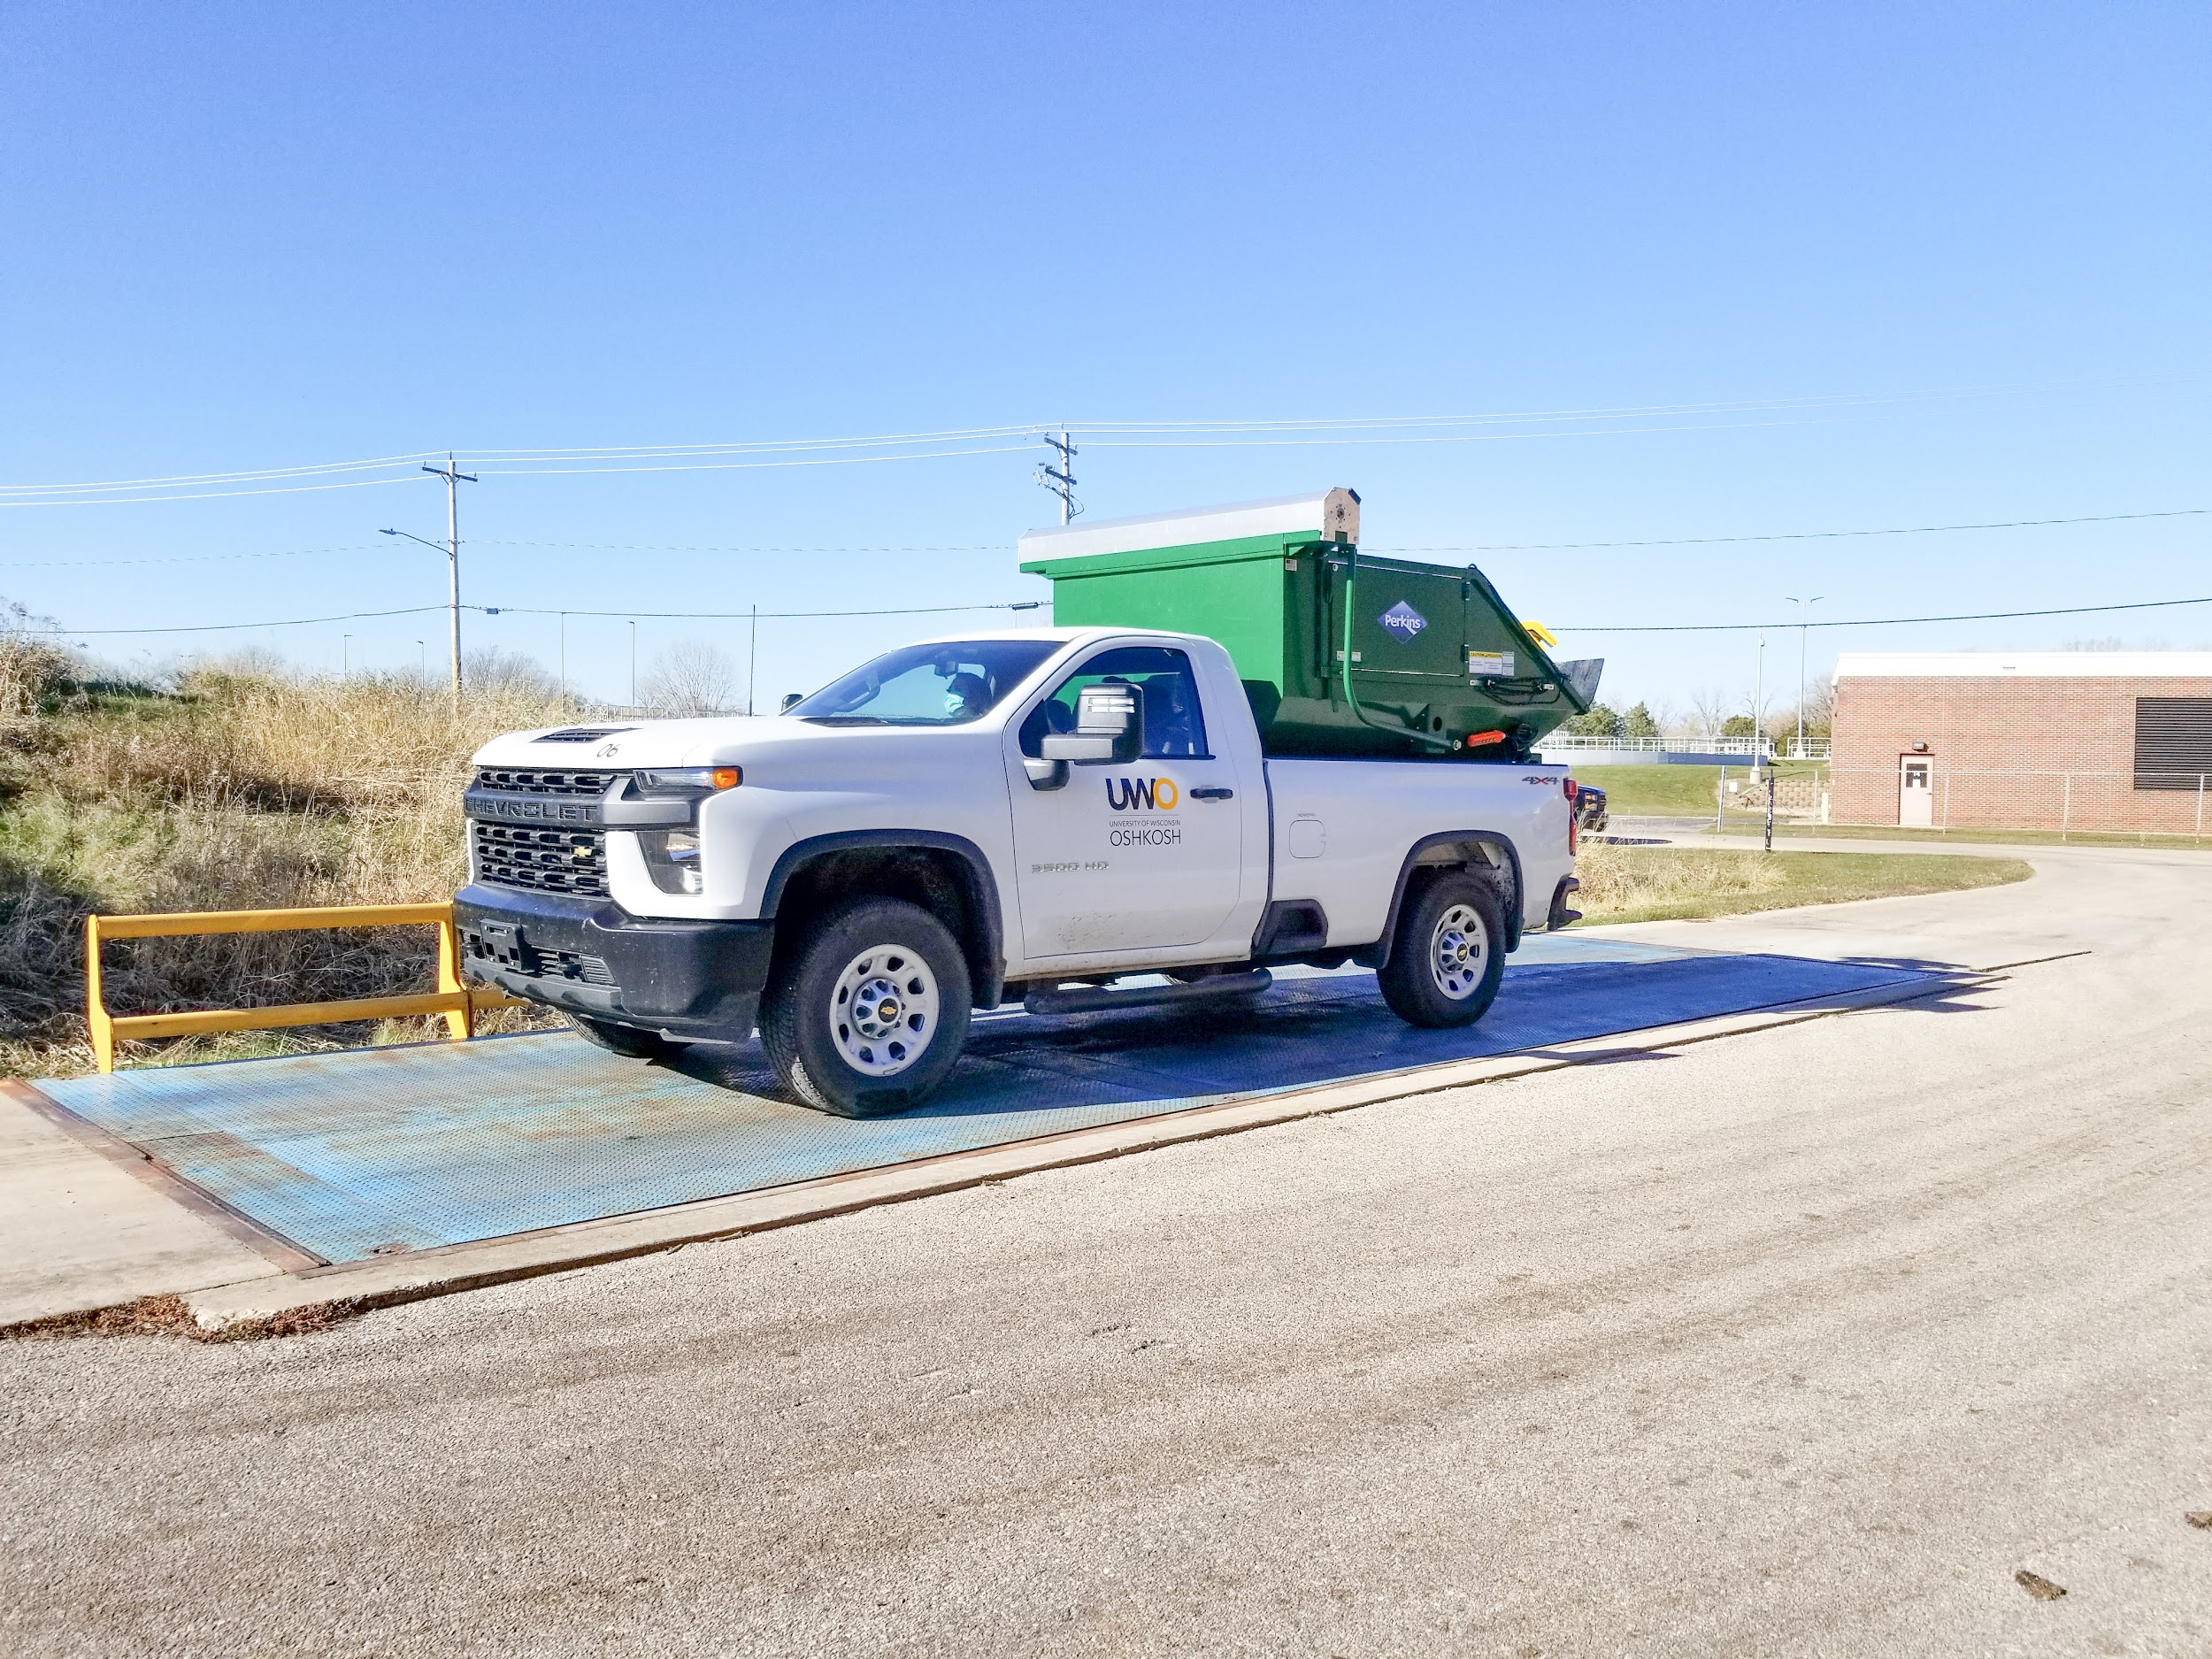
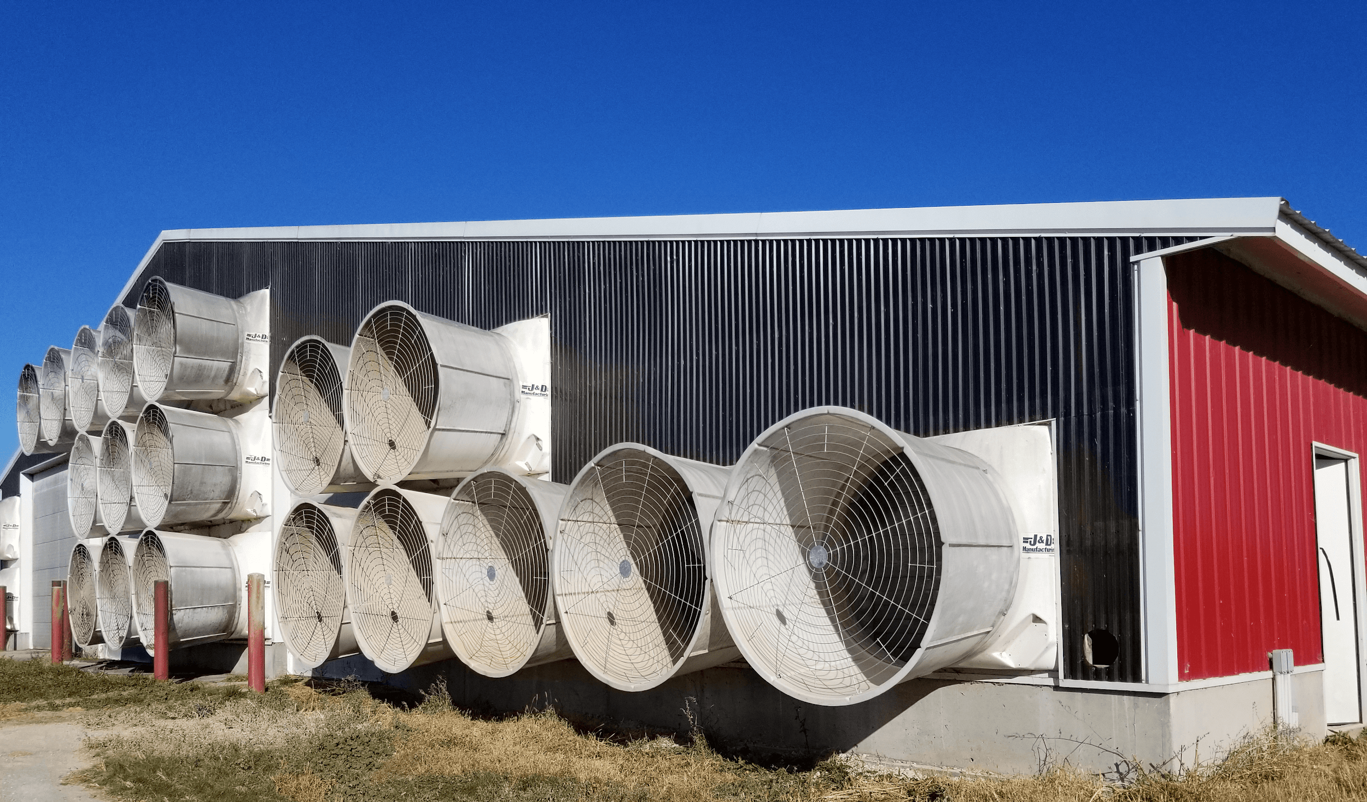
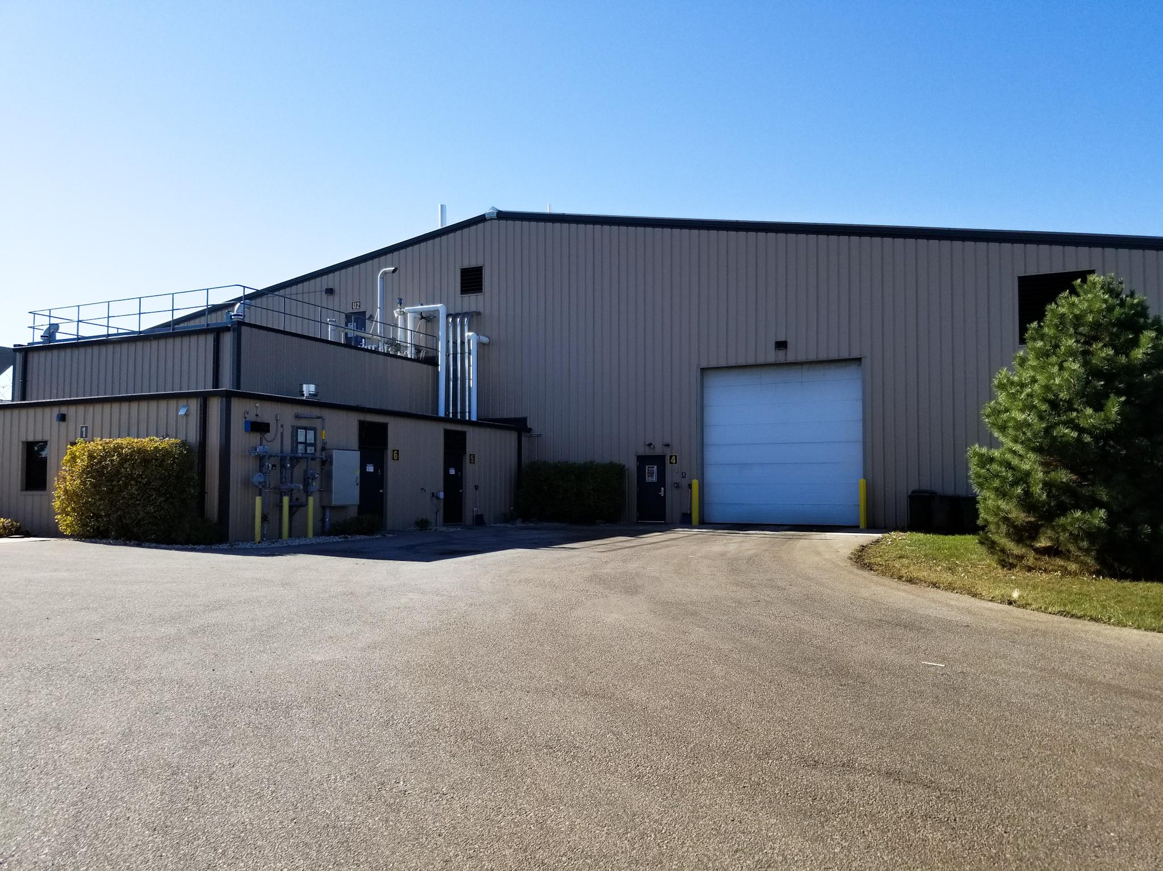

Deliverable 5:
Infographics:
The strategy behind the infographics is the impact and magnitude of biogas programs can be difficult to understand; infographics can make understanding these concepts easier by breaking down a concept or by making a comparison. According to AgSTAR Project Development Handbook, one of the best ways to talk about renewable energy non-profits is to talk about the economic and environmental help they provide to the community (EPA, “AgSTAR Project Development”, 2014).
The tactic we used was to explain in a more meaningful way the amount of waste biogas could stop from entering landfills and the number of homes this energy could power in Wisconsin. These infographics show the relevance of the biogas programs to the state and why they should matter to residents.
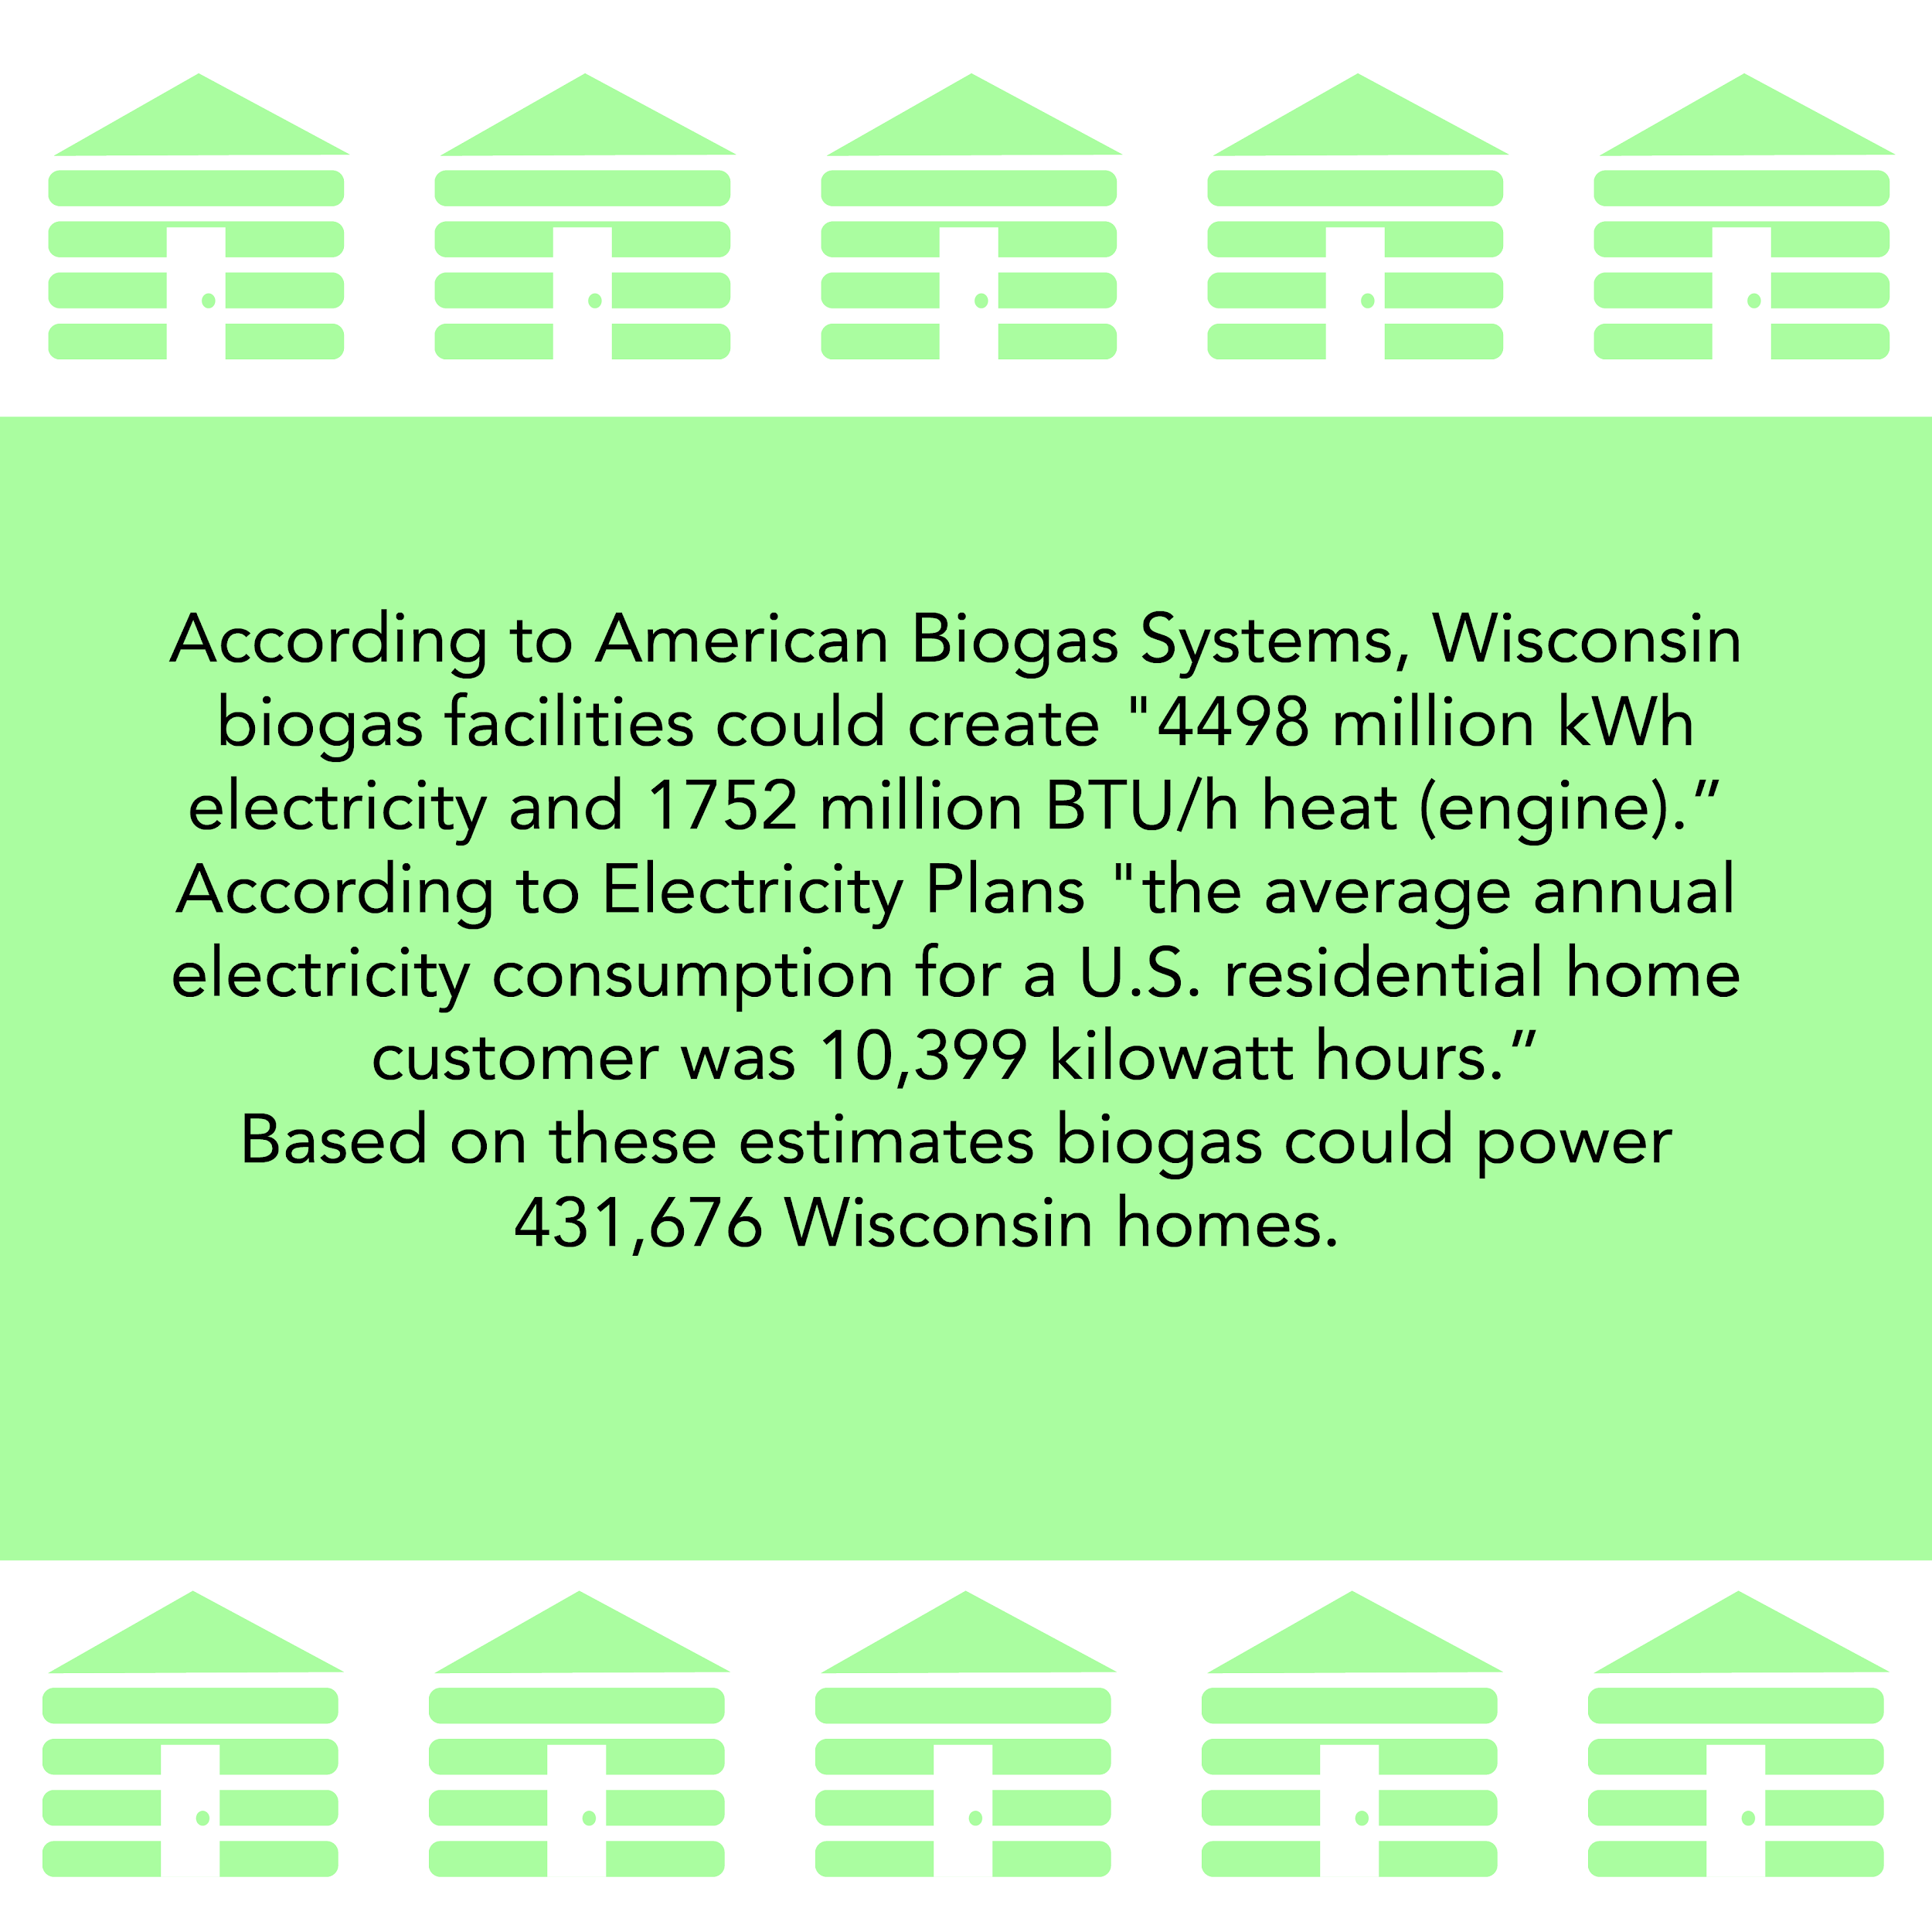
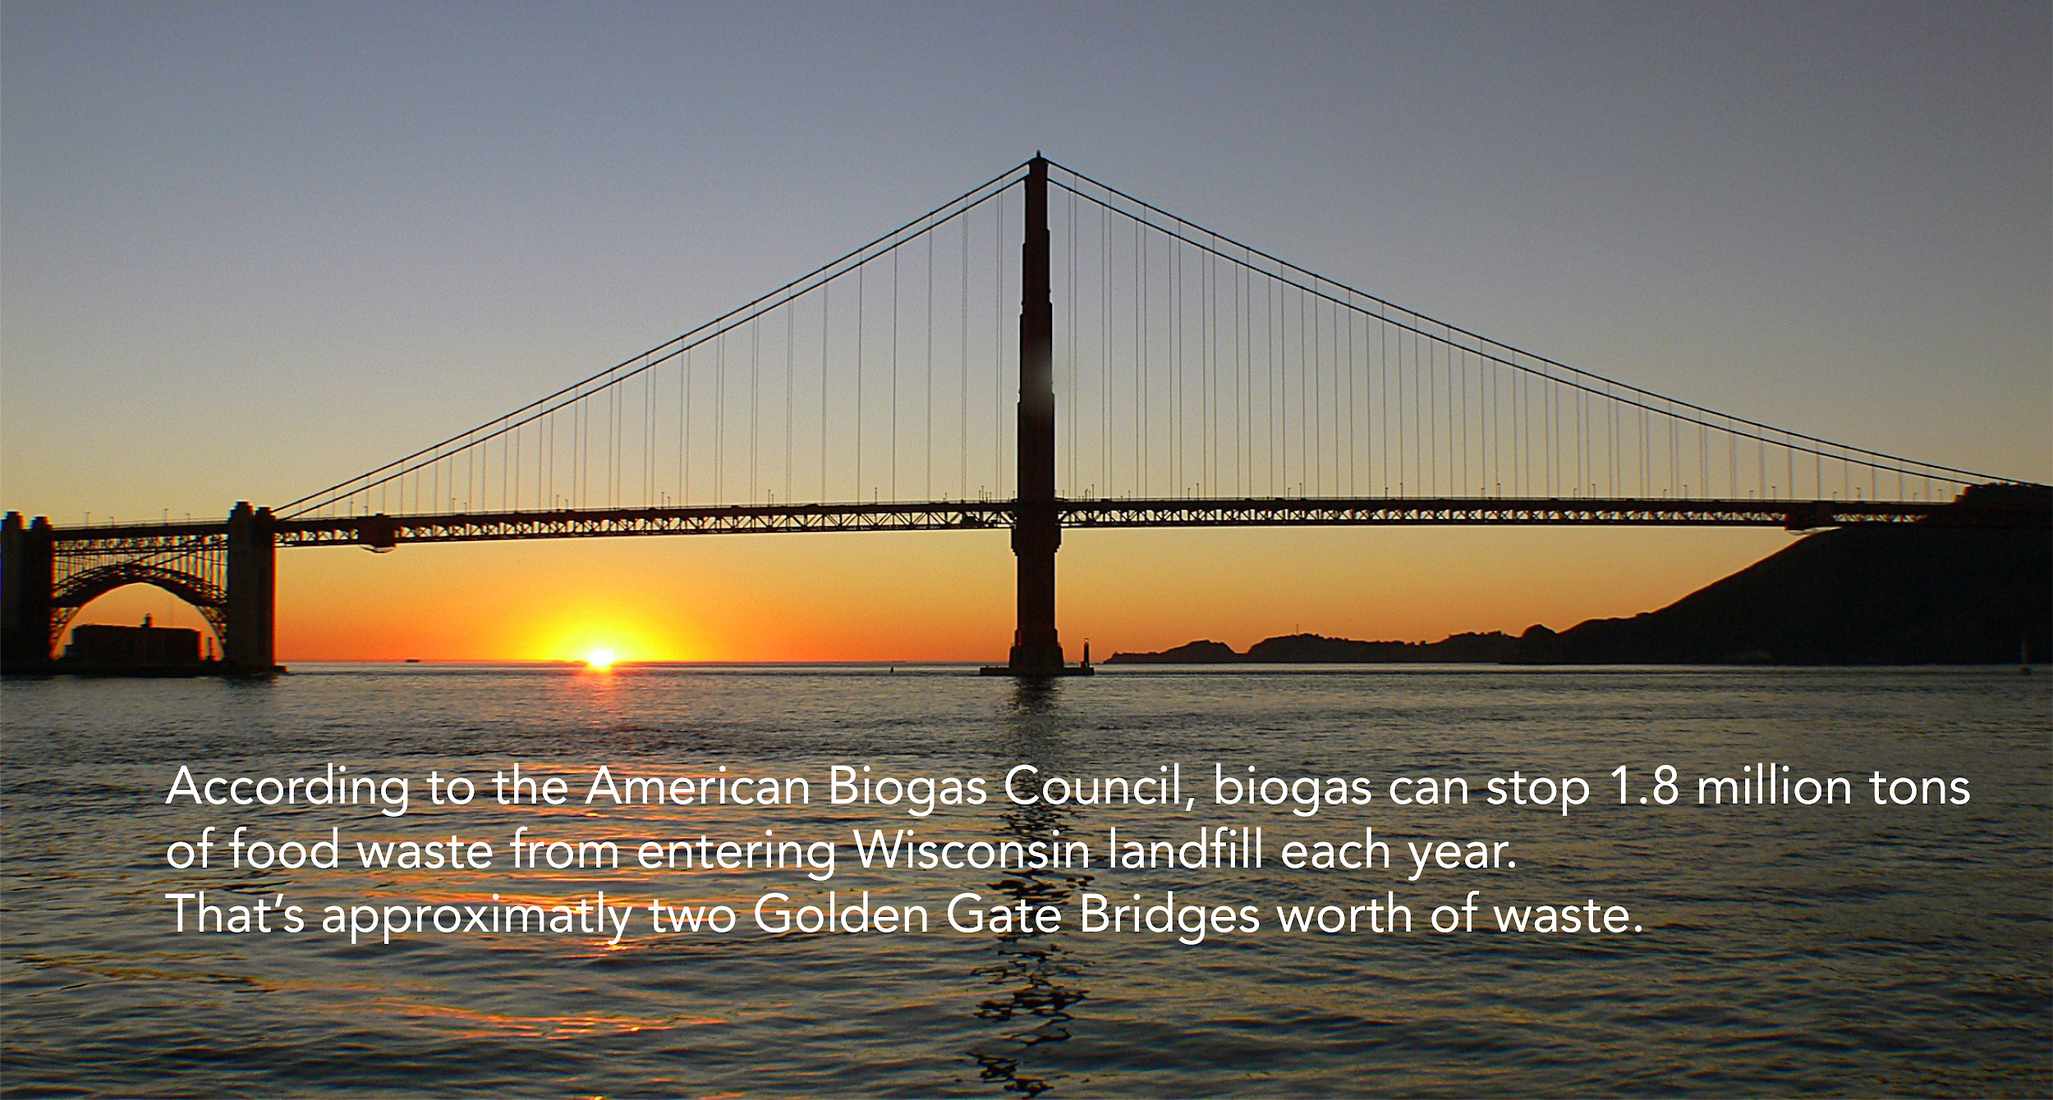
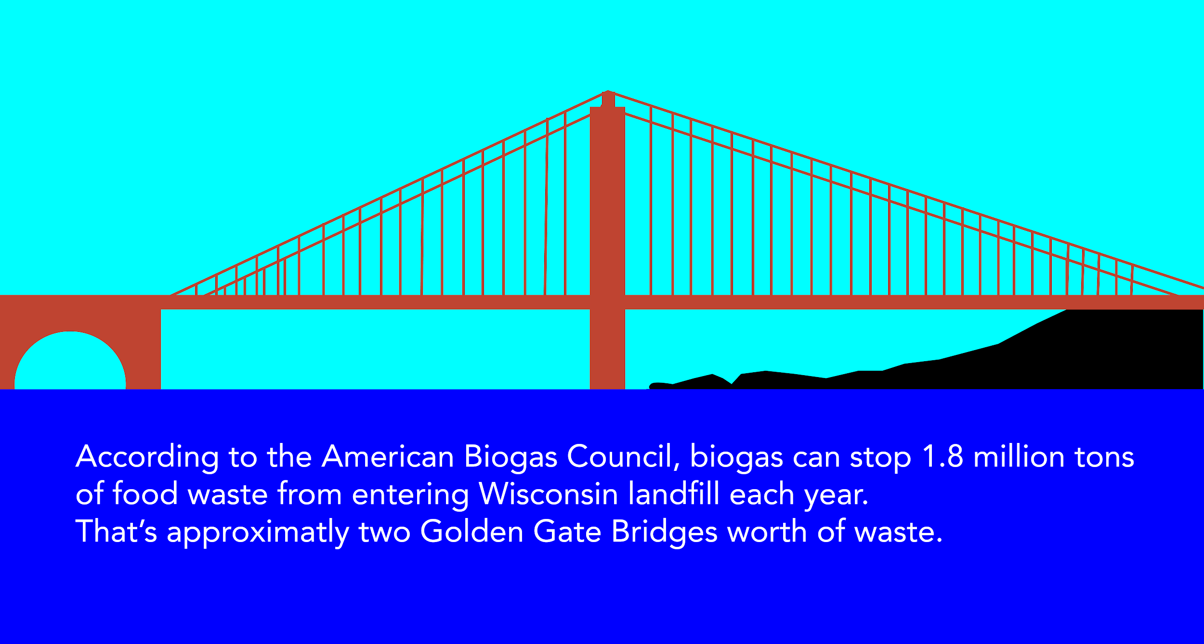

These infographics can be used on the website, on social media or in future videos for the biogas program.

Measuring Project Success:
UWO Biogas can measure the success of their new website by using an analytics plugin on WordPress. An analytics plugin will allow them to view statistics about their website, such as number of sessions, page views, bounce rate, and average session duration. By using these analytics, they can determine possible changes that can be made to the website, and also get a better understanding of their target audience.
The video success can be measured by the number of views on YouTube.
Future Recommendations:
When or if you have time and or resources to do so, start up social media pages they can help attract students, community members and professionals to UWO Biogas Program.
Also, expand upon the consultation page. Go in-depth on what UWO Biogas Program did for each of these organizations, and include pictures or video if you can. Many companies like Ameresco and Greenfire have thorough case studies for many of their projects.
Timeline for implementation of deliverables:
A timeline for implementation of deliverables is within the next month. Once any last changes are made, the website can then go through approval with UMC. After the website is approved and live the videos can then be used on the site and/or placed on social media. Along with the photos and infographics.
Future Budget:
The only budgeting concern from a marketing/public relations perspective is if you want to have ads when UWO Biogas has a social media account. However, this is a fairly minor concern and the UWO Biogas Program does not have to have paid advertising anyway.

Appendix
“AgSTAR Project Development”, Environmental Protection Agency, 2014, https://www.epa.gov/sites/production/files/2014-12/documents/agstar-handbook.pdf
Bergstrom, 2018, https://coschedule.com/blog/social-media-best-practices-for-business/
Clarke, 2020, https://blog.hootsuite.com/social-media-best-practices/
“Distributed Generation, Microgrids & Storage.” Ameresco, 2020, https://www.ameresco.com/renewable-energy/
“GreenFire.” GreenFire Management Services, 2020, http://greenfire.com/
“Facts About Biogas” Biogas Research Center, 2020. https://biogasresearchcenter.se/facts-about-biogas/?lang=en
“Here’s Our Story.” Agra Energy, 2020, http://agraenergy.com/heres-the-story/
“Operator School.” American Biogas Council, 2020, https://americanbiogascouncil.org/operator-training/
“Renewable Energy Website Templates.” Motocms, 2020, https://www.motocms.com/website-templates/category/alternative-power/
Shore, 2020, https://www.smartbugmedia.com/blog/17-linkedin-marketing-best-practices
“Social Media Best Practices.” Tufts University Relations, 2020, https://communications.tufts.edu/marketing-and-branding/social-media-overview/social-media-best-practices/
“Non Profit Web Design: Best Practices”, Andrew Slade, June 2020, https://www.deepblue.com/non-profit-web-design-best-practices/
“UW Oshkosh Biogas Systems.” Biogas Systems, 11 Apr. 2019, uwosh.edu/biogas/ .
Walker-Ford, Mark. “5 Reasons You Should Use Video on Your Website [Infographic].” Social Media Today, 3 Oct. 2017, www.socialmediatoday.com/marketing/5-reasons-you-should-use-video-your-website-infographic
“What Is Biogas? A Beginners Guide.” Homebiogas, www.homebiogas.com/Blog/142/What_is_Biogas|fq|_A_Beginners_Guide
“Why Biogas?” American Biogas Council, 2020, https://americanbiogascouncil.org/resources/why-biogas/
“What is Environmental Sustainability?” The Balance Small Business, 2020. https://www.thebalancesmb.com/what-is-sustainability-3157876
“Wisconsin Biogas Profile.” American Biogas Council, 2020, https://americanbiogascouncil.org/wp-content/uploads/2020/06/ABC-2020-State-Profiles-49.pdf
“10 Best solar energy website examples.” Creative Nurds, 2020, https://www.creativenurds.com.au/10-best-solar-website-designs
“10 Website Design Best Practices for Nonprofits.” Nonprofit Tech for Good, 23 June 2020, www.nptechforgood.com/2020/01/05/10-website-design-best-practices-for-nonprofits/.
“27 Eye-Opening Website Statistics: Is Your Website Costing You Clients?.” SWEOR, 5 March 2020, https://www.sweor.com/firstimpressions

UWO Biogas Program Infographics, https://drive.google.com/drive/folders/17zNT2J1aaotVe2IaVU1oz2JJlwiqPY29?usp=sharing
UWO Biogas Program Urban Anaerobic Dry Biogas Systems photos, https://drive.google.com/drive/folders/1Db1SqqhaYuXDlj3VmBPTL65ikhxp0HMu?usp=sharing
UWO Biogas Program Allen Farms photos, https://drive.google.com/drive/folders/1G4eaoOKMb9a9c0Hlnw6YEZ90WrNW-Gjy?usp=sharing
UWO Biogas Website PDF’s
https://drive.google.com/drive/folders/1A3yAGlALjHF6RcckqFR7yMbyvg60admW?usp=sharing

UWO Biogas Videos, https://drive.google.com/file/d/13_mP4XX8SbLPnQbnLOwVOJ0DwmnIyzv5/view?usp=sharing
UWO Biogas Social Media Guide, https://docs.google.com/document/d/1-Q4xVI4tF4LMLehikRdszZJk2CJYXFv84rR4DZ3hWIQ/edit?usp=sharing

